- \Operation\Inserting\Insertion
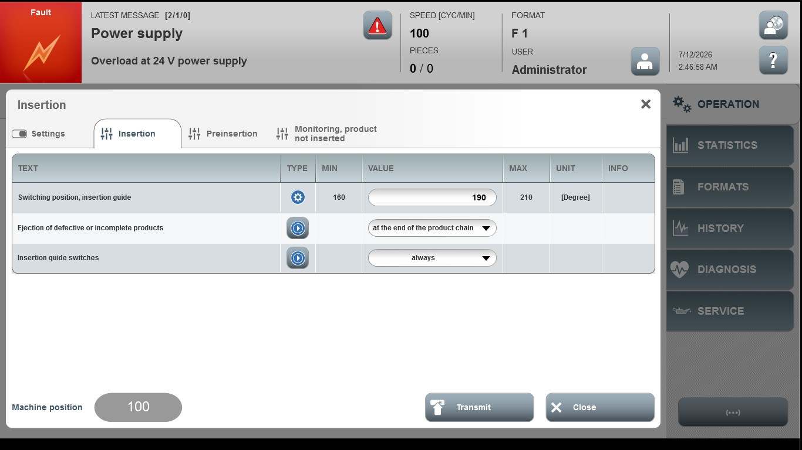

Acceptance criterion | Limits | Pass / Fail: Dev-No. | Date | Initials
Screen matches screenshot | N / A
Switching position, insertion guide | 160 … 210

